ANNEX 1 – Hotel Map
THE 18TH ASIAN SHIPOWNERS’ FORUM
Traffic Direction to Evergreen Plaza Hotel (Tainan)

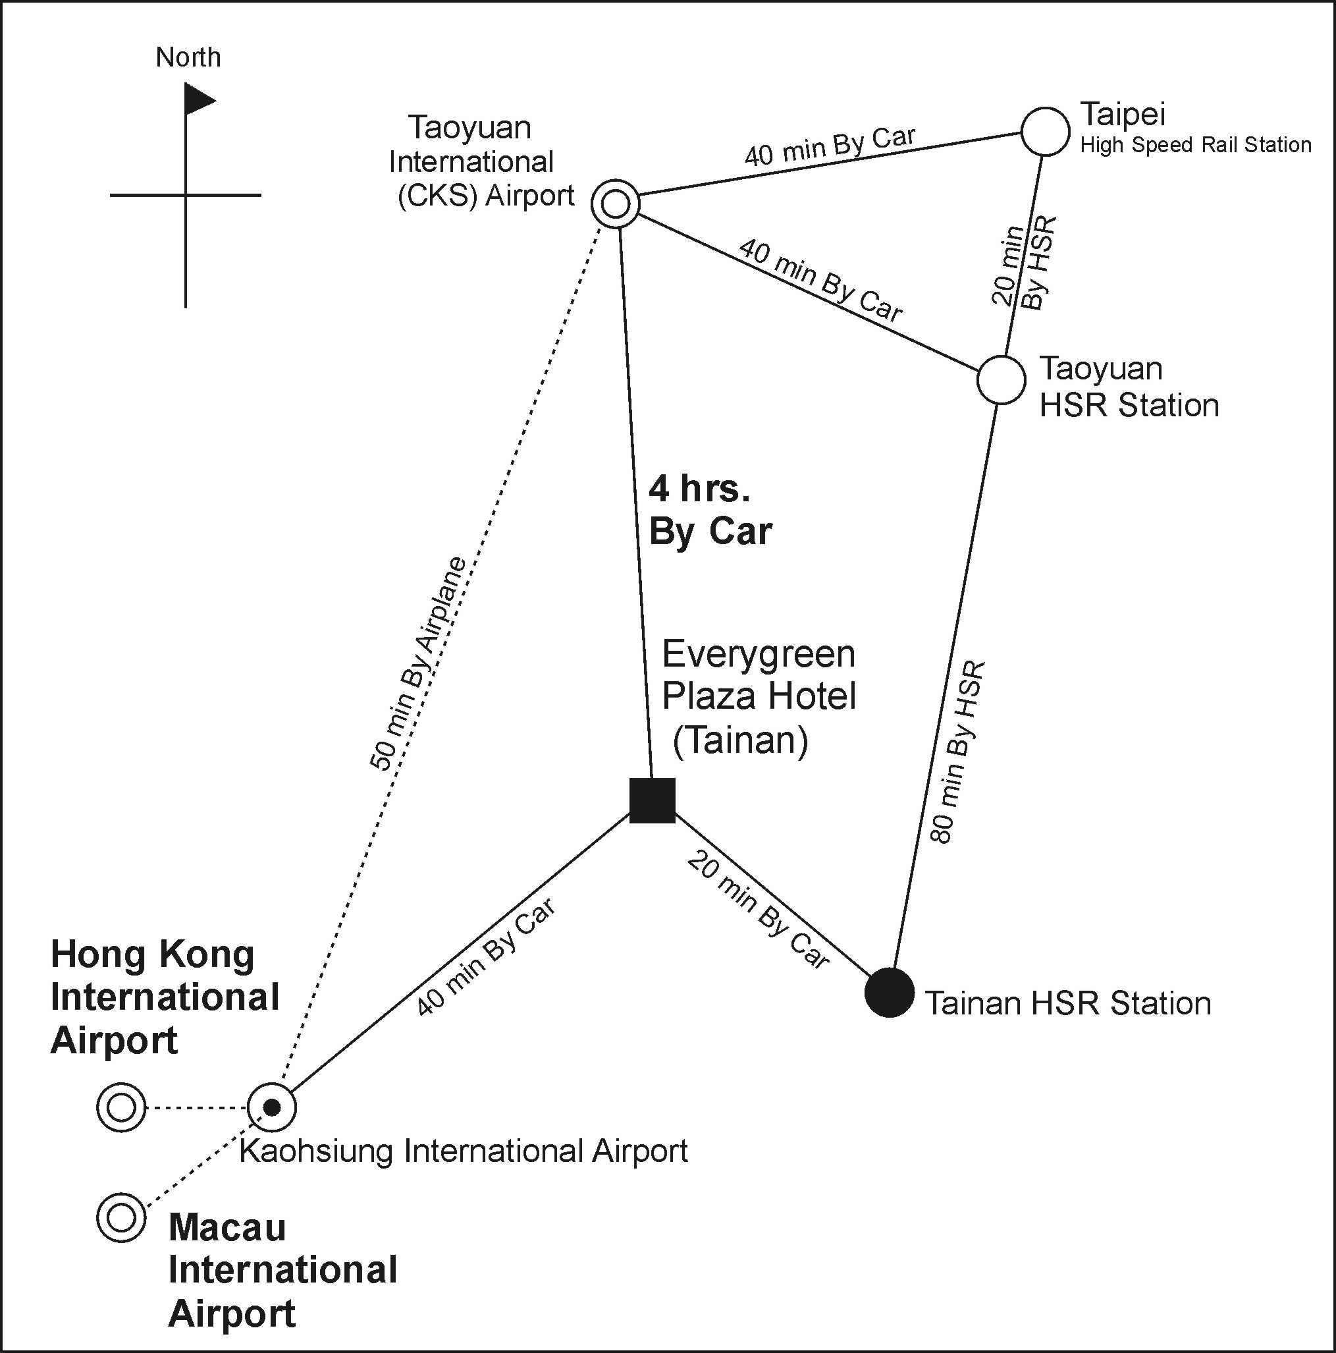

Remarks:
ASF Shuttle Service
1. Pick up Point 1 -- Kaohsiung International Airport.
2.■ Pick up Point 2 -- Evergreen Plaza Hotel (Tainan).
3.● Pick up Point 3 -- Tainan High Speed Rail Station.

